Your child is on the Blue Books
To date, your son/daughter will have learnt one way in which each long vowel sound is written (Set 2 sounds). When learning their Set 3 speed sounds they will be taught that there are more ways in which the same sounds are written, e.g. ‘ee’ as in tree and ‘ea’ as in tea.
They will be working on ‘Blue books’. These are more complex books including fiction and non-fiction titles, which provide an opportunity to practise the new sounds they have learned. They will also be working on a range of writing tasks related to these books. There are 20 Set 3 ‘speed sounds’ that are made up of two or three letters which represent just one sound, e.g. ‘ea’ as in tea, ‘ow’ as in cow and ‘are’ as in care. These are also known as ‘digraphs’ or ‘trigraphs’. As before, it is important that your daughter/son does not pronounce these as 2 or 3 separate sounds. When your daughter/son sees the ‘speed sound’ letters together in a word, s/he must say just one sound for these letters.
When your daughter/son learns their Set 3 sounds in school, they will learn:
- The letters that represent a speed sound e.g. ‘ea’
- A simple picture prompt linked to the ‘speed sound’ and a short phrase to say e.g. ‘cup of tea’.

Set 3 Sounds and Phrases
ea: cup of tea | oi: spoil the boy
a-e: make a cake | i-e: nice smile
o-e: phone home | u-e: huge brute
aw: yawn at dawn | are: care and share
ur: purse for a nurse | er: better letter
ow: brown cow | ai: snail in the rain
oa: goat in a boat | ew: chew the stew
ire: fire fire | ear: hear with your ear
ure: sure it’s pure? | tion: celebration
tious/cious: scrumptious/delicious | e: he, me, we, she, be
tious/cious: scrumptious/delicious | e: he, me, we, she, be
tious/cious: scrumptious/delicious | e: he, me, we, she, be

Every speed sound has a list of green words linked to it so your child can ‘sound out’ and ‘sound blend’ words containing the new speed sound they have just learnt e.g. s-p-oi-l spoil.

Your child may have remained in this group. This means they need to consolidate the Set 3 sounds and improve their reading fluency. Fluency is ‘reading a text aloud accurately with appropriate expression and pacing that reflects the meaning of the text’.
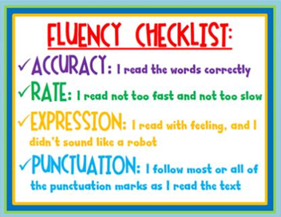
Please note that there is no correlation between the Read, Write Inc colours for group progression and the link book band reading scheme colours. They are separate schemes with a separate colour progression. However, through discussion with your child’s class teacher, your child’s link book will be at a similar level to their Read, Write Inc book.
Children need to be secure in all of the above and be reading at approximately 70+ WPM (words per minute) to move into the next colour group.
Red Ditties
Green | Purple
Pink
Orange
Yellow
Blue
Grey
Off the Programme

If you have any questions about the Read, Write Inc programme or your child’s progress, please do not hesitate to request an appointment to speak to your child’s teacher or our Read, Write Inc Lead – Mrs Markham (l.markham@hernejunior.com).

