Year 6 Homework, Spring Term Week 9

Maths: Super Six

- What is ninety multiplied by seventy?  - Round 3.61 to one decimal place.  - 10.89x 10  - What is four-fifths of twenty?  - 10.43 – 4.8  - Which fraction is equal to ⅛?  ⁴⁄₆ ⁴⁄₃₀ ²⁄₁₆ | 1) Work out the surface area of a cube of edge 3m?  2) A yogurt costs 75p. How many yogurts can be bought for five pounds?  3) If x + y = 10, find the value of y when x = 3  4) In a group of 45 children, there are twice as many boys as girls. How many girls are there?  5) If 75% is £45, what is the full cost?  6) Which is bigger: 17.5% or ?

PSHE homework:
As part of your PSHE unit on Careers, we would like you to interview an adult about their job. There is a suggested questionnaire in your classroom or online to help you. Find out what qualifications or experience is needed for the job, what they enjoy about the job, any areas they don’t enjoy (please do not ask the adult about their wage) Please bring in your questionnaires on a separate piece of paper so they can be put into your PSHE books and can be used in PSHE.

Maths Extension:

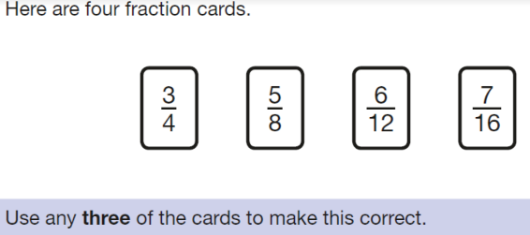

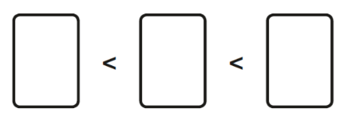

Spellings

Support | Core | Extension
vibration  inflation  dictation  nation  action  fraction  station  relation  relationship  mention  other  mother  door  good  imagine  medicine | subjection  subjective  loaf  loaves  wetter  wettest  variety  variation  variable  primate  primitive  primary  discovered  discovery  waste  waist  through  thought  critic  criticise | Occupation  Accurate  Eccentric  Accomplish  Accelerate  Impeccable  Succulent  Accommodate  Accommodation  Please complete 3 sentences using vocabulary from the Words to sharpen your expression list (click on this link).

