Year 6 Homework, Summer Term Week 7
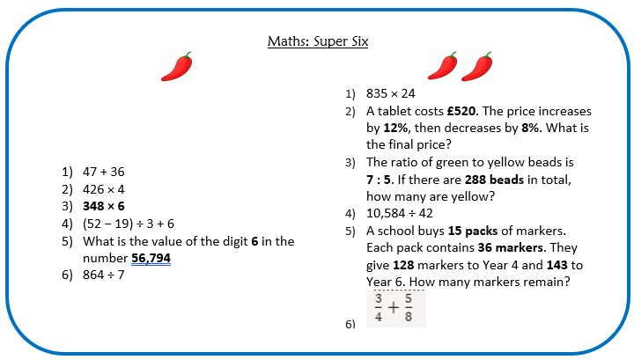

Reading Comprehension:
Complete Florence Nightingale comprehension

SPAG activity
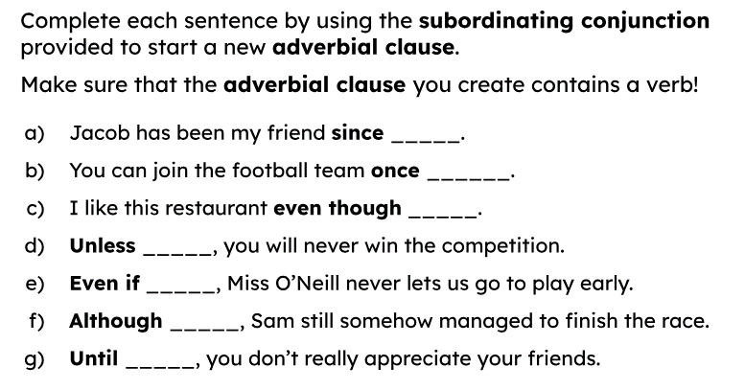

Spellings

Support | Core | Extension
act  actor  action  activity  react  reaction  electric  electrical  electricity  electrocute  electronic  electrician  mistake  mistaken  overtaken  partaking  once  place  symbol  system | difference  beautiful  handkerchief  explosion  earthly  decimal  contribution  city  factory  inland  zoology  hydrogen  supernatural  agoraphobia  resources  periscope  suddenly  air  shoulder  soldier

