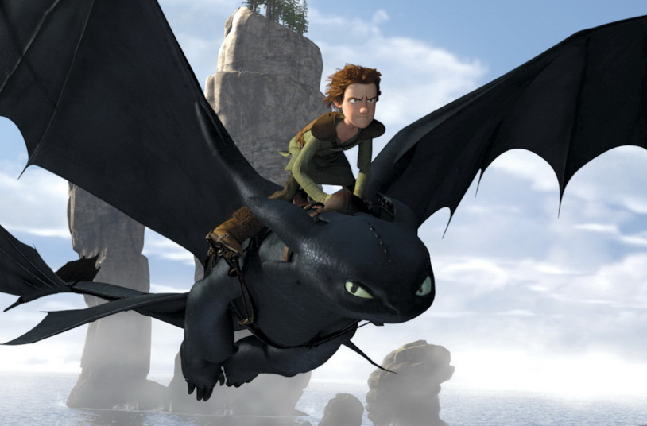
Medium term planner – Literacy Revision Unit.

Title and duration: How to Train Your Dragon / Crossing the White Line: Walter Tull / The Witches / A Shakespeare play / Titanic

Year group: Year 6:

Description: The children will be introduced to the ‘Seven Marvellous Ways to be a Magical Writer’. They will then revise these skills and a variety of genre features using these five topics. Children will be engaged through the use of film, books, drama and a wide range of source material.

Hook: The children will be introduced to each topic with a variety of media to inspire their writing. For the Witches and How to Train Your Dragon the children will study a quality text and animated film. For the unit on Walter Tull the children will experience WW1 poetry and assorted original source material relating to Walter’s life, his legacy and the war. For the unit on Titanic the children will study the real life tragedy using a variety of sources including film extracts and first-hand accounts of some of the survivors. As an end of year production the children will perform a Shakespeare play.

Learning value 1:
- To begin to develop their own ‘writer’s voice’.
Learning value 2:
- The use of empathy in their writing for the purposes of engaging the reader and adding realism.
Quality Texts:
- The Witches by Roald Dahl
- Walter Tull; a variety of archived sources
- Shakespeare –
- A variety of historical sources for Titanic.

Literacy:
-Focus on the 7 Marvellous Ways to be a magical writer to ensure that the children are including the key ingredients in their writing. Their writing will include,
-Description
-Recount
-Instructions
-Journalistic report
-Non chronological report
-Poetry
-Persuasive letter
-Atmospheric recount
-Biography
-Play script
-Information text
-Diary

Application subject: To support their literacy work: they will look at the life of a soldier in WW1; study Shakespeare and one of his plays; research historical sources relating to the sinking of the Titanic.

Application subject: They will apply their watercolour skills learned in Art to create their own design of a witch and dragon. They will use the stained glass window of World War I poet Edward Thomas as an example to create their own commemorative window for Walter Tull.

Outcome: Children will feel more confident in their ability to identify the features of different genre and use them in their own writing. The children will have the opportunity to empathise with people from History and learn how their lives have enriched our society.
Potential links to local, national, international communities: Children will be using the stained glass window of World War I poet Edward Thomas with a visit to a local church as inspiration.
Home study: Children come up with a mnemonic to remember ‘the Seven Marvellous Ways to be a magical Writer’ and complete an individual project about the Titanic.
ICT – The children will evaluate different software (Word, Prezi, Explain Everything) and hardware (iPads) and their use in presenting their literacy work.
RRR and Values Links: Empathy, self-sacrifice, equality, racism, bigotry and positive thinking.

