Year 4 Homework, Spring Term 2 Week 11 - Support

**Maths**

|  |  |  |
| --- | --- | --- |
|  |  | |
|  | |

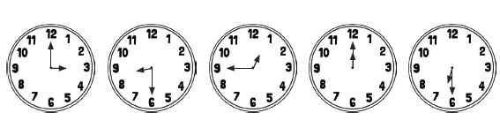

Write the time shown on each clock.

**Quick Comprehension:** Have a go at the reading comprehension. Children should try to read the text, remember to decode any tricky or new words. Give yourself five to ten minutes to answer the questions. Some of the questions are quite tricky, so don’t worry if you have to talk them through with an adult. Your parent can write your answers for you.

**Spellings**

wood

soot

good

pool

look

hook

wool

cook

foot

two

**SPaG Challenge in books please**



**Times Tables Activities**

**Please do some of the following:**

Daily times tables on TT Rockstars

Daily chanting and oral questioning

Hit the Button – Times tables

Please remember: All homework is marked in class with the children and will not have written feedback on it.

Homework is due in on the following Friday