Year 4 Homework, Spring Term 2 Week 11

**Maths: Fun Five!**

pm

pm

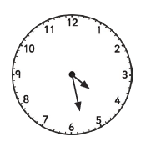

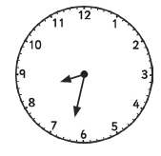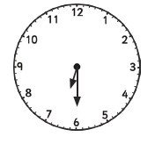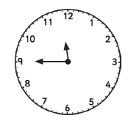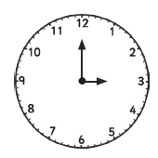



Write down the time shown on each clock.



Write the time shown on each clock in analogue, digital and 24 hours.

e.g. 3pm = 3:00pm = 15:00

**Quick Comprehension:** Complete the reading comprehension. Children should allow themselves one minute to read the text, and five/ten minutes to answer the questions. Some of the questions are quite tricky, so don’t worry if you have to talk them through with an adult.

**Spellings**

|  |  |
| --- | --- |
| **Core**  away  awake  asleep  around  another  alive  belief  beliefs  chief  chiefs  other  any  mother  keep  ordinary  therefore | **Support**  isn’t  doesn’t  won’t  I’d  I’ll  I’m  she’s  it’s  there’s  paid  laid  maid  my  you  favourite  group |

|  |
| --- |
|  |

**SPaG Challenge in books please**



**Times Tables Activities**

**Please do some of the following:**

Daily times tables on TT Rockstars

Daily time tables in booklet

Times tables training grid

Times tables wheels

Daily chanting and oral questioning

Please remember: All homework is marked in class with the children and will not have written feedback on it.

Homework is due in on the following Friday.