Year 4 Homework, Spring Term 2 Week 10 - Support
Maths

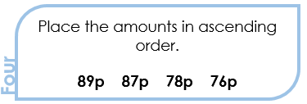


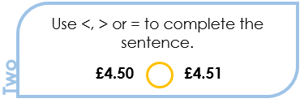
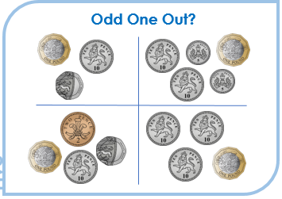



Quick Comprehension: Have a go at the reading comprehension. Children should try to read the text, remember to decode any tricky or new words. Give yourself five to ten minutes to answer the questions. Some of the questions are quite tricky, so don’t worry if you have to talk them through with an adult. Your parent can write your answers for you.

Spellings

loud
shout
found
noun
round
pound
sound
spout
out
too
SPaG Challenge in books please

Times Tables Activities
Please do some of the following:
Daily times tables on TT Rockstars
Daily chanting and oral questioning
Hit the Button – Times tables

Please remember: All homework is marked in class with the children and will not have written feedback on it.
Homework is due in on the following Friday

