Sports funding grant expenditure 2016-17

Number of pupils and sports funding received
Total Pupils on Roll | 452
Sport Funding received | £4256 (29/4/16) £10, 132 predicted for the year

Use of funding | Cost
Transport and staff costs to take more children to level 2 and 3 competitions | £3000
Training for staff (including support with teaching, planning and assessment) | £1000
Hosting of tournaments | £200
PE equipment | £2500
Financial support for gifted and talent children to take part in county and national competitions | £300
Young Sports Leader training | £1000
Multi-skills and balance work intervention sessions | £1000
Lunchtime equipment | £500
TBC (contingency money) | £632

Provision

The school enters a vast range of Level 2 competitions put on by the Havant Sports Partnership – including hockey, tennis, rounders, football, basketball, Swimming, Tag Rubgy.. etc.
Staff have had access to a sequence of staff training with external specialists, including looking at the new curriculum, planning, support with teaching and learning and assessment
New sporting equipment has been purchased, including new basketball hoops, new football goals, new multi-skills equipment..etc
The school has been encouraging county and national participation – including sending a trampolining team to the national finals and tennis plays to the Hampshire Games
New lunchtime sporting equipment has been purchased to help encourage physical activity at the lunchtime

Success Criteria

More children in school to have access to sporting competition (50% target)
Staff feel more confident in teaching PE
Children to reach age expectations in PE
Children to get a wide range of sporting activities throughout the curriculum
Children to have a better understanding of how to live a healthier lifestyle
Children in school are fitter and healthier
School being awarded School Games Gold Award (for the second year)

Review 2016-17
Number of children involved in extra-curricular sport 2015-16 was 62%.
Number of children involved in extra-curricular sport 2016-17 was 85%

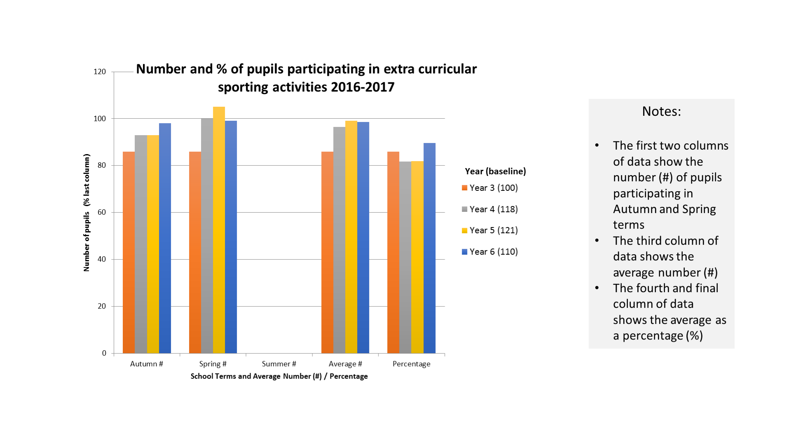

The school achieved a School Games GOLD award
Some of the schools success stories in the 2015-16 academic year were:
Winners of the Havant Area Rounders Tournament
Winners of the HJS Girls Football Tournament
Winners of the Girls Football Havant League
Winners of the Les Petter Boys Football Tournament
Runners-up Havant and Portsmouth Area Girls swimming festival
Third Place in the Girls Football Tournament at the Hampshire Games
We also took part in: cross country running, multi-skills festival, athletics, kit-car racing and gymnastics.

