Year 7 Recommended Reading List

Classics:
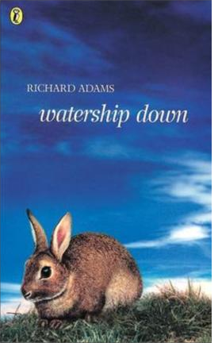
Adams, Richard Watership Down
Buchan, John The Thirty Nine Steps
Dahl, Roald Skin; Tales of the Unexpected; Boy; Going Solo
De Saint-Exupery, A The Little Prince
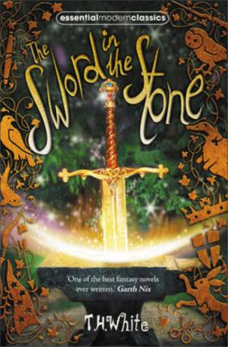
Dickens, Charles Oliver Twist; A Christmas Carol Doyle, Sir Arthur Conan The Adventures of Sherlock Holmes Gallico, Paul The Snow Goose; The Small Miracle Haggard, H. Rider King Solomon’s Mines
Johns, Captain W. E. Biggles Learns to Fly; Biggles Flies East London, Jack The Call of the Wild; White Fang Stevenson, R. L. Treasure Island
Tolkein, J.R.R The Hobbit
White, T.H. The Sword in the Stone

Great Stories:
Almond, David Skellig
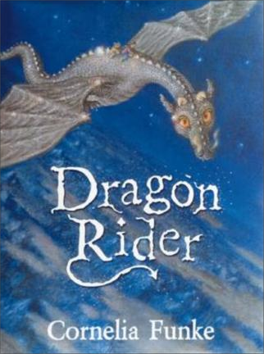
Blackman, Malorie Hacker; Antidote
Bowler, Tim Starseeker; Midget; River Boy; Apocalypse
Breslin, Theresa Death or Glory Boys; Remembrance
Burgess, Melvin Kite; Billy Elliot; An Angel for May; The Cry of the Wolf
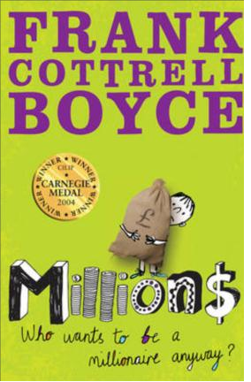
Cottrell Boyce, Frank Millions
Creech, Sharon Walk Two Moons; Ruby Holler Cross, Gillian Born of the Sun; Wolf; New World Dhami, Narinder Annie’s Game
Dowd, Siobhan The London Eye Mystery
Funke, Cornelia The Thief Lord; Inkheart; Dragon Rider
Garfield, Leon Mr Corbett’s Ghost; Smith
Golding, Julia Wolf Cry
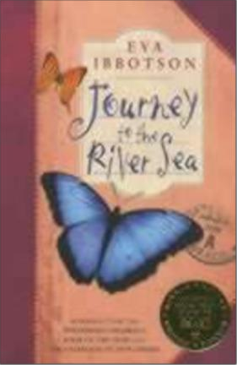
Ibbotson, Eva Journey to the River Sea
Jacques, Brian Redwall (series); Martin the Warrior Laird, Elizabeth A Little Piece of Ground; Garbage King Le Guin, Ursula Earthsea Quartet
McCaughrean Geraldine A Pack of Lies; Stop the Train Morpurgo, Michael War Horse; The War of Jenkins’ Ear Paver, Michelle Chronicles of Ancient Darkness Paolini, Christopher Inheritance trilogy
Pullman, Philip Northern Lights; The Subtle Knife; The Amber Spyglass Reeve, Philip Mortal Engines; Predator’s Gold; Infernal Devices Riordan, Rick Percy Jackson (series)
Ridley, Philip Dakota of the White Flats; Mercedes Ice; Scribbleboy
Sachar, Louis Holes; Small Steps
Stroud, Jonathan The Amulet of Samarkand; The Golem’s Eye
Updale, Eleanor Montmorency (series) Winterton, Jeanette Tanglewreck

Funny:
Durrell, Gerald My Family & Other Animals
Feeney, Josephine My Family & Other Natural Disasters
MacFarlane, A. Diary of a Teenage Health Freak

Historical:
Cornwell, Bernard Sharpe series; Heretic; Vagabond; Harelquin
Doherty, Berlie Street Child
Frank, Anne The Diary of Anne Frank
Fraser, Antonia King Arthur & the Knights of the Round Table
Gardner, Sally I, Coriander; The Red Necklace
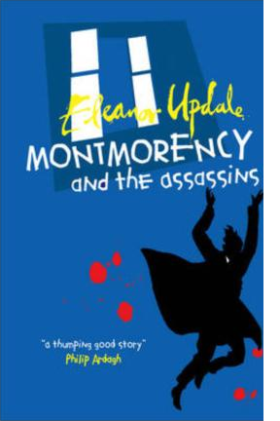
Geras, Adele Troy; Cleopatra
Paton Walsh, Jill The Dolphin Crossing
Sutcliff, Rosemary Eagle of the Ninth; The Lantern Bearers
Treece, Henry The Viking Saga; The Children’s Crusade

Useful websites: www.lovereading4kids.co.uk www.achuka.co.uk www.booktrustchildrensbooks.org.uk

