Year 5 Recommended Reading List

Classics
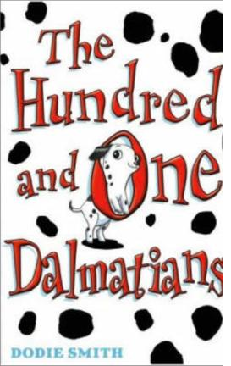
Anderson, Hans Christian Selected Tales of Hans Anderson
B. B. Brendon Chase; Down the Bright Stream Burnett, F. Hodgson The Secret Garden; Little Lord Fauntleroy Dahl, Roald Danny; Champion of the World
Grahame, Kenneth The Wind in the Willows
Hughes, Ted The Iron Man
Kipling, Rudyard The Jungle Book
Langley, Noel The Land of Green Ginger
L’Engle, Madeline A Wrinkle in Time
Lewis, C. S. Chronicles of Narnia
Linklater, Eric The Pirates in the Deep Green Sea
Nesbitt, Edith The Treasure Seekers; The Railway Children
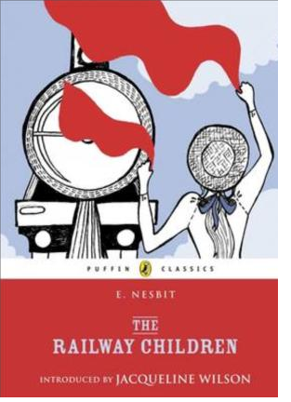
Norton, Mary The Borrowers
O’ Brien, Robert C. Mrs Frisby & the Rats of Nimh
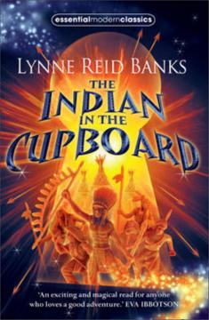
Smith, Dodie 101 Dalmations; Streatfield, Noel Ballet Shoes Tolkein, J. R. R. The Hobbit White, E. B. Charlotte’s Web
Wilde, Oscar Fairy Tales of Oscar Wilde

Great Stories:
Banks, Lynne Reid Indian in the Cupboard (series)
Byng, Georgia Molly Moon’s Hypnotic Time Travel Machine
Cowell, Cressida How to be a Pirate
Diterlizzi, Tony Spiderwick Chronicles (series)
Druitt, Tobias Corydon & the Island of Monsters; Corydon &
the Fall of Atlantis
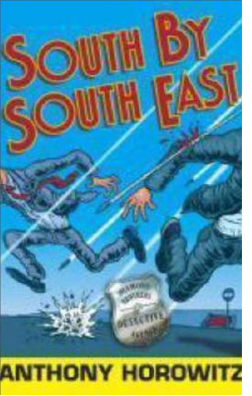
Fine, Anne Goggle Eyes; Madame Doubtfire Fisk, Nicholas Grinny; Space Hostages; Trillions Fletcher, Charlie Stone Heart; Iron Hand
Foreman, Michael War Game; War Boy
Gavin, Jamilia Grandpa Chatterji; I Want to be an Angel & Other Stories
Geras, Adele Cleopatra; A Candle in the Dark
Gleitzman, Morris Stickybeak; Toad Heaven; The Gift of the Gab Golding, Julia The Chimera’s Curse - Companions Quartet Hinton, Nigel The Finders; Beaver Towers series
Horowitz, Anthony Groosham Grange; Diamond Brothers (series) Jarvis, Robin The Alchemyst’s Cat; The Woven Path
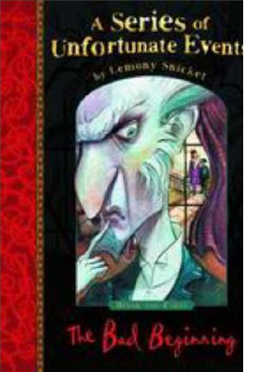
Juster, Norton The Phantom Tolbooth
McEwan, Ian The Daydreamer
Morpurgo, Michael The Wreck of the Zanzibar, The Amazing Story of Adolphus Tips
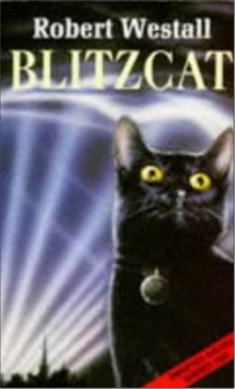
Nimmo, Jenny The Snow Spider Trilogy
Palacio RJ Wonder
Pearce, Philippa A Dog so Small; Minnow on the Say Pullman, Philip I Was a Rat; Count Karlstein Riordan, Rick Percy Jackson (series)
Snicket, Lemony A Series of Unfortunate Events
Stannard, Russell Uncle Albert (series) Stewart & Riddell Fergus Crane Westall, Robert Blitzcat
Wynne-Jones, Diana Charmed Life

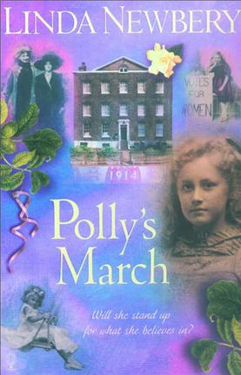
Historical:
Foreman, Michael War Game; War Boy
Kerr, Judith When Hitler Stole Pink Rabbit; Bombs on Aunty
Dainty
Lawrence, Caroline The Thieves of Ostia; The Pirates of Pompeii
McCaughrean, Geraldine One Thousand & One Arabian Nights Treece, Henry The Viking Saga; The Children’s Crusade Turnball, Ann et al. Historical House (series)

Useful websites:

www.lovereading4kids.co.uk www.achuka.co.uk www.booktrustchildrensbooks.org.uk

