Year 3 Recommended Reading List

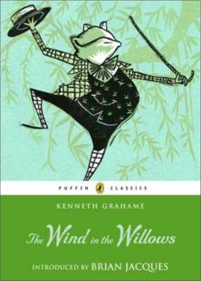
Classics
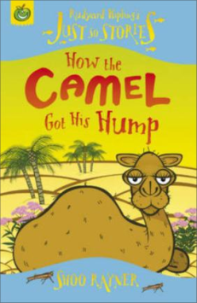
Carroll, Lewis Alice in Wonderland (adapted by Lesley Sims) Crompton, Richmal Just William (adapted by Martin Jarvis)
Dahl, Roald The Twits, The Magic Finger Grahame, Kenneth The Wind in the Willows Milne, A A Winnie the Pooh
Potter, Beatrix Tales of Peter Rabbit
Rayner, Shoo Rudyard Kipling’s Just So Stories (adapted)
White E B Stuart Little

Great fiction
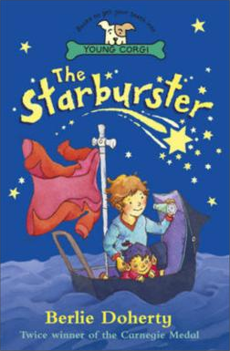
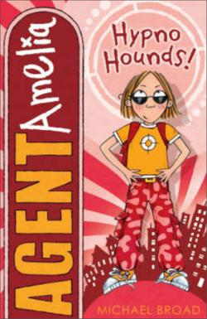
Allan Ahlberg The Children Who Smelled a Rat Blackman, Malorie The Monster Crisp Guzzler Bradman, Tony Happy Ever After (series)
Broad, Michael Agent Amelia (series) Brown, Jeff Flat Stanley
Burchett, J Wild Rescue: Ocean S.O.S (series) Child, Lauren Clarice Bean (series)
Childs, Rob Wicked Day! Daniels, Lucy Animal Ark (series)
D’Lacey, Chris The Dragons of Wayward Crescent
Doherty, Berlie The Starburster Fine, Anne Diary of a Killer Cat Friel, Maeve Witch in Training
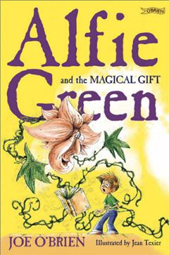
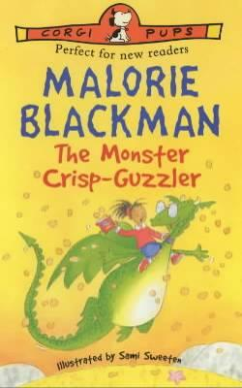
Frost, Adam Harry Rabbit on the Run
Gray, Kes Daisy (series)
Griffiths, Andy The Big Fat Cow that Goes Kapow
Johnson, Pete Invisible Brother King-Smith, Dick The Hodgeheg McDonald, Megan Judy Moody (series) McGowan, Anthony Bare Bum Gang (series)
McLaughlin, Marilyn Fierce Milly & the Amazing Dog
Morpurgo, Michael The Dancing Bear
Murray, Martine Henrietta the Great Gogetter
Nimmo, Jenny Invisible Vinnie
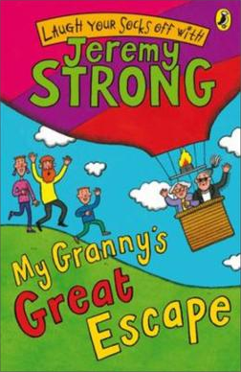
O’Brien, Joe Alfie Green & the Magical Gift (series) Owen, Laura Winnie the Witch (series)
Pattern, Brian Impossible Parents
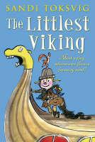
Rai, Bali Soccer Squad: Stars (series) Rees, Gwyneth Fairy Gold
Ryan, Margaret Scratch and Sniff
Stine, R L Rotten School (series) Strong, Jeremy My Granny’s Great Escape Toksvig, Sandi The Littlest Viking
Tomlinson, Jill The Owl who was Afraid of the Dark
Whybrow, Ian Boy Racer
Wilson, Jacqueline Video Rose

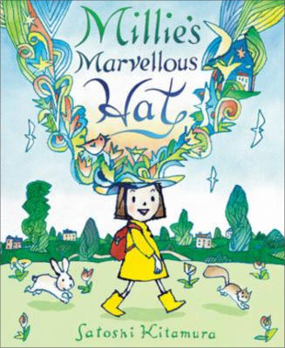
Picture Books
Browne, Anthony Silly Billy
Dodd, Emma Miaow said the Cow Donaldson, Julia A Squash & a Squeeze Goodheart, Pippa You Choose
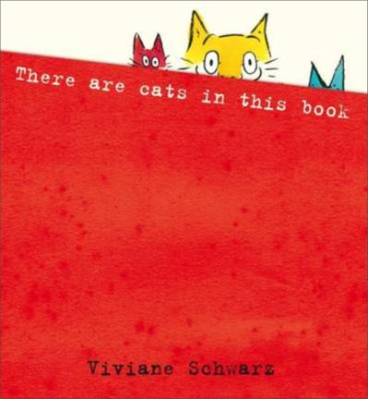
Gravett, Emily Monkey & Me
Kitamura, Satoshi Millie’s Marvellous Hat Jeffers, Oliver The Great Paper Caper Schwarz, Viviane There are Cats in this Book

Books in italics are ideal for sharing.

Corgi Pups, Walker Stories and The Magic Tree House all publish great stories for this age range, by a variety of well-known authors.

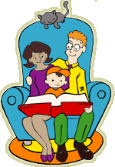
Useful websites: www.lovereading4kids.co.uk www.achuka.co.uk www.booktrustchildrensbooks.org.uk

